**Introduction**

Some teachers have considered how to balance the educational engagement with students and their professional development. There are previous studies indicating that teachers' professional development will increase by more engagement on students’ education and reviewing assessment. This study used data in TALIS 2018 Teacher Questionnaire Public-Use File to analyze the relationship between teachers’ educational engagement and their professional development. Thus this study hypothesizes that teachers who work more on developing students' test-taking skills may agree that they have higher quality and higher ready accessibility of professional development; teachers who work more on administering, proctoring, and scoring mandated assessments may agree they have higher quality and higher ready accessibility of professional development; and teachers who work more on reviewing and analyzing results of mandated assessments to improve instruction may agree that they have higher quality and higher ready accessibility of professional development.

**Method**

Datas in TALIS 2018 Teacher Questionnaire Public-Use File are used for analyzing teacher’s working hours on students’ development and assessment may have higher agreement that they have higher quality and accessibility of professional development. There are three types of work on students for teachers: students’ test-taking skills, administering, proctoring, and scoring mandated assessments, and reviewing and analyzing results of mandated assessments. The agreement on quality and accessibility of professional development is measured by four levels (1=strongly disagree, 2=disagree, 3=agree, 4=strongly agree).

**Result**

Total six correlation tests are used to analyze the relationship between teachers’ working hours and their agreements on professional development. There is no significant relationship between working time on students’ test-taking skill and agreement on quality of professional development, working time on scoring assessments and quality and accessibility of professional development, and working time on analyzing results of mandated assessments and accessibility of professional development.

Results indicated that teachers’ working time on students’ test skills was significantly correlated with accessibility of professional development, r(2397) = 0.048, p = .016. From the scatterplot (See Figure 1), it can be seen that the relationship was positive. Thus, as teachers’ working time on students’ test skills increased, accessibility of professional development increased.

Besides, results indicated that teachers’ working time on reviewing assessments was significantly correlated with quality of professional development, r(2397) = 0.045, p = .026. From the scatterplot (See Figure 2), it can be seen the relationship was positive. Thus, as teachers’ working time on reviewing assessment increases, the quality of professional development increases.

**Figure 1**

*Scatterplot for working time on students’ test skill and accessibility of professional development*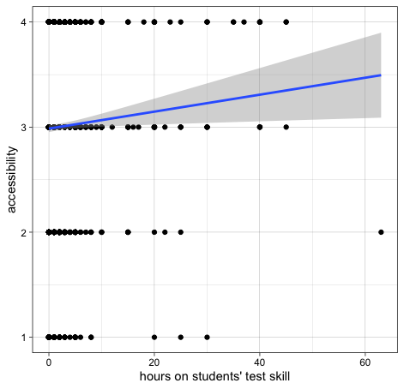

*Note.* X-axis is teachers’ working hours on students’ test skill and Y-axis is agreeableness on having high accessibility of professional development: 1-strongly disagree, 2-disagree, 3-agree, 4-strongly agree.

**Figure 2**

*Scatterplot for working time on reviewing assessments and quality of professional development*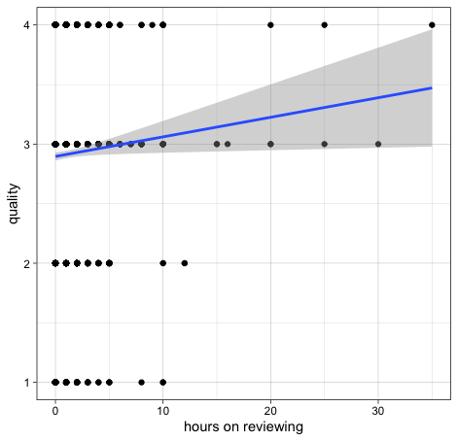

*Note.* X-axis is teachers’ working hours on reviewing assessments and Y-axis is agreeableness on having high quality of professional development: 1-strongly disagree, 2-disagree, 3-agree, 4-strongly agree.